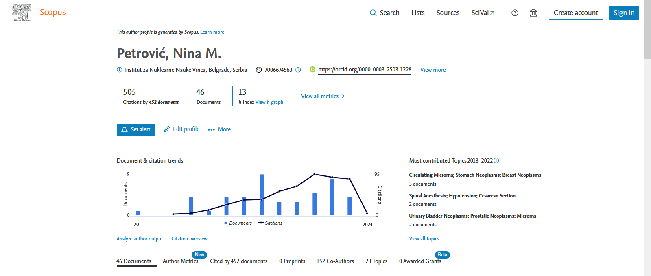

https://ezproxy.nb.rs:2071/authid/detail.uri?authorId=7006674563#tab=cited-by

